GulfTalent Crawler Guide

GulfTalent Crawler is a tool that is able to extract all jobs from a provided URL of the Gulf Talent website. It is customized to extract Company Name, Location, Job Description, Job Posting Date and Employment Type in this version. It is an easy-to-use tool which able to scrape in the background without any interference. Multiple of customizations are provided to run the tool as per user needs. This document will contain explanation of each such customization and how to use it easily.

**Running the tool**

To run the tool, first launch the provided exe and you’ll be greeted with a screen shown below.

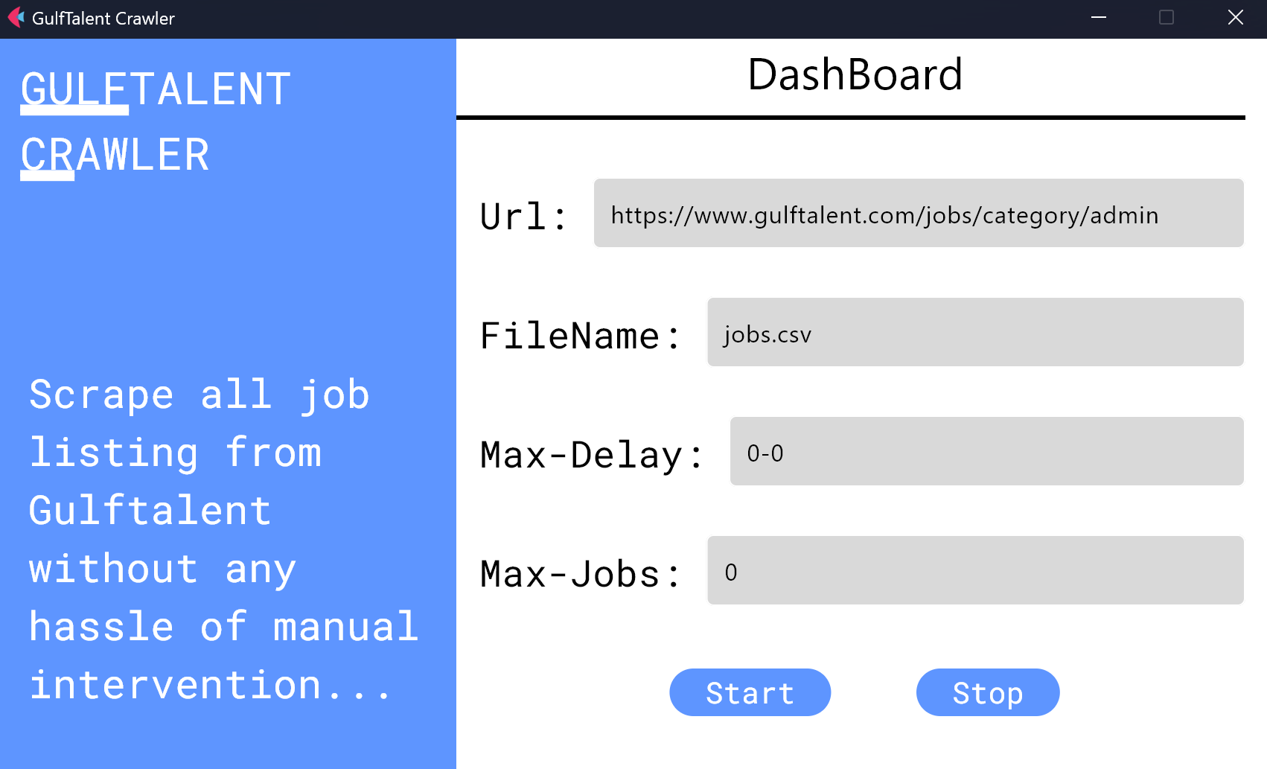

Just press the “Start” button and it will run the scraper in the background, once it has completed the scraping, you’ll be shown an alert box confirming that the bot has completed the task.

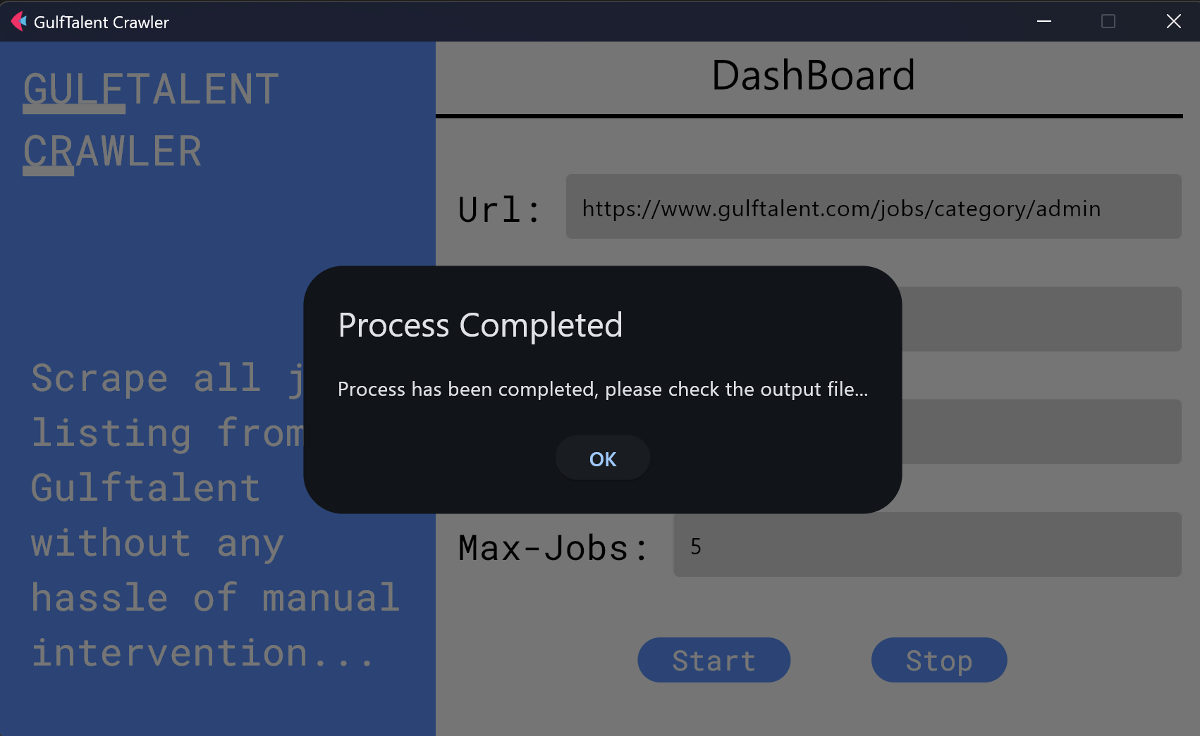

You can find the output file in the same folder where the exe is placed, if used with default settings, a file called as “jobs.csv” will be present in the folder.

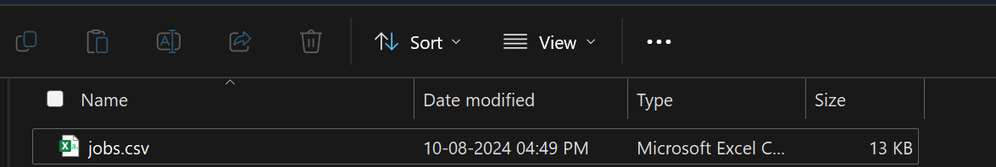

If the bot needs to be stopped, you can simply press the stop button, and once you’re presented with an alert box saying it has been stopped.

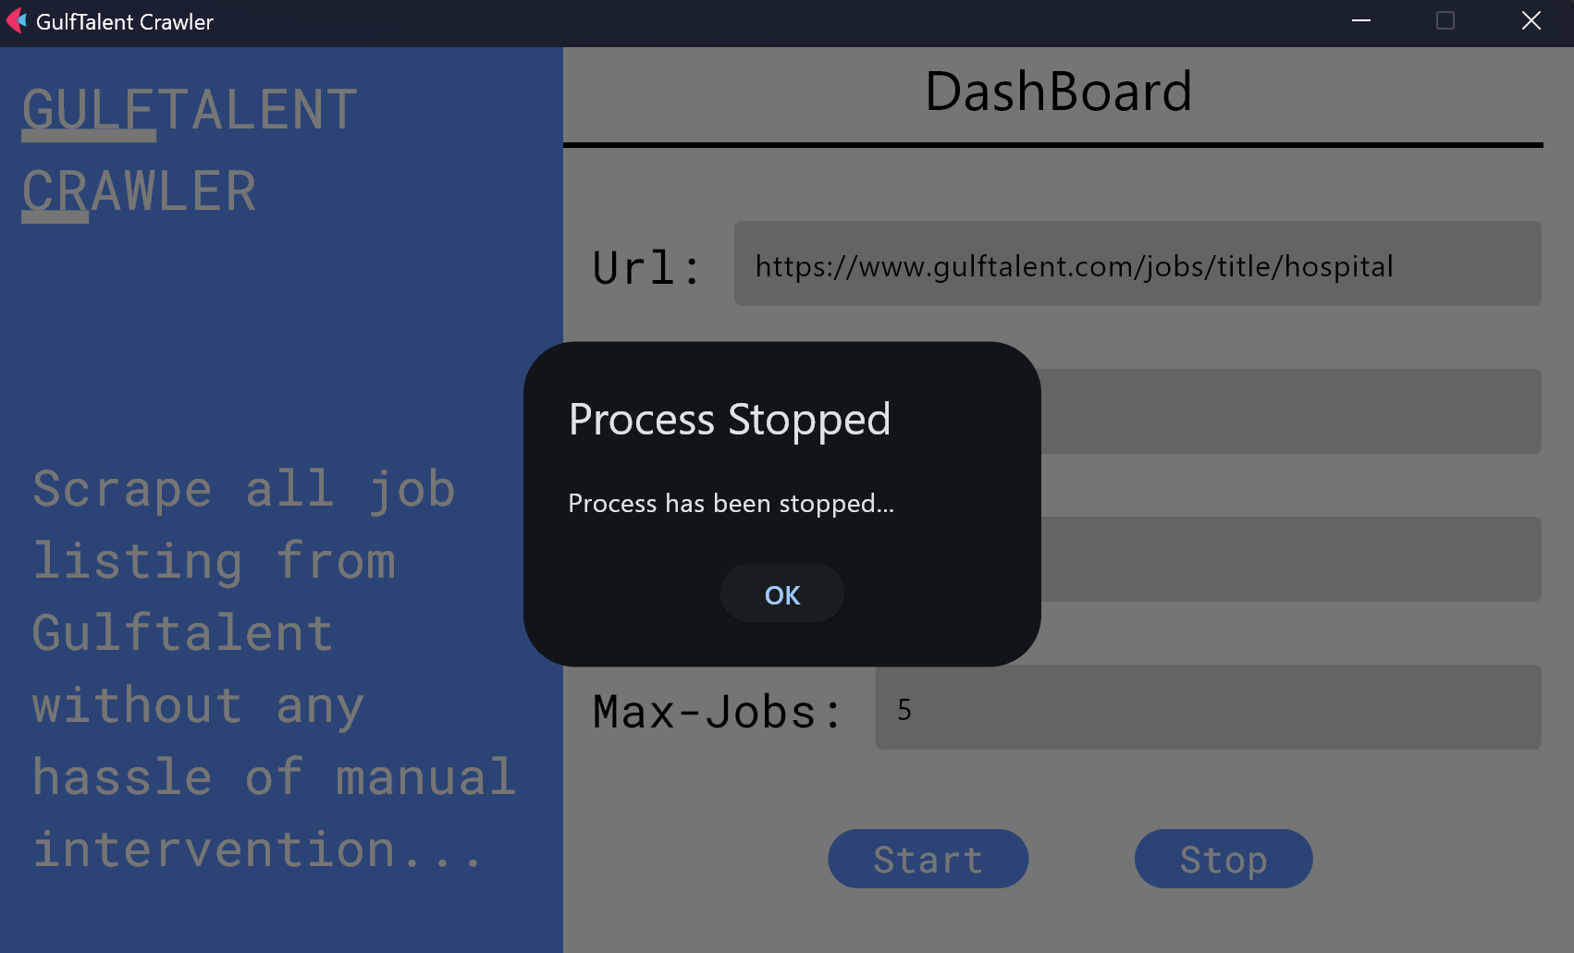

**Customizable Options**

**URL –** You can enter any URL of GulfTalent site that you want to scrape, make sure it is the job board which has the list of all jobs and not just the job link you want to save.

**FileName –** By default the final export file where data will be saved is named as jobs.csv, but you can rename it to whatever you like, make sure this field is never empty as the program will not be able to start.

**Max-Delay –** Each time a link is scraped, the bot will stop for a bit of time, by default this time is set to be between 1-3 seconds, if you wish to change it you can simply enter your numbers, make sure there are no decimals and always the 2 numbers are mentioned, if you want the bot to stop for let’s say at least 3 seconds after scraping an entry and maximum about 10 seconds then write as 3-10 in the field.

**Max-Jobs –** If you want to scrape only a specific number of entries such as let’s say the top 50 entries only, then you can enter that number here and the bot will save only those number of job posts, but if you wish to save all of them then simply enter 0 which is by default present in the settings as well.

Here I’m showing an example settings configuration where the bot will save top 10 entries, file name is all_jobs.csv and there is a delay of 2-5 seconds.

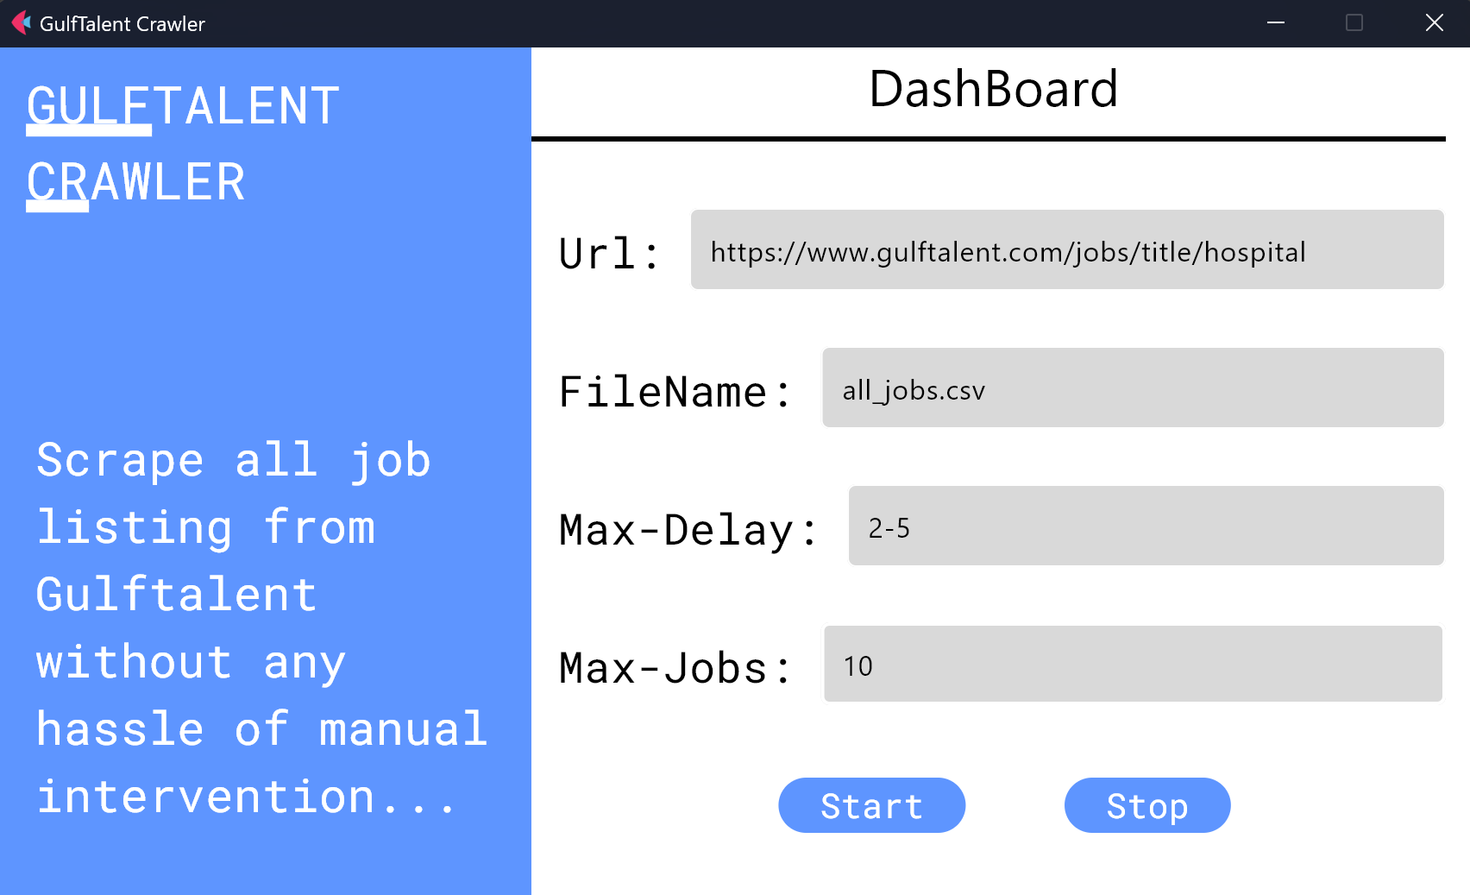

Here is another one where I’m scraping all of the jobs, file name is entries.csv and it will have a delay of 1 second only.

